PRE K 131 | Khorie Allen
PRE K 145 | John Ramos
PRE K 111 | Maliyah Howard
K 138 | Samani Turner
K 147 | Ashley Espinosa
K 140 | Gabriella Chavez
1-113 | Ivan Wang
1-134 | Jakye Joseph
2-340A | Tamia Smith
2-340B | Jason Lu
3-234A | Cindy Lu
3-234C | Shakira Goode
4-322B | Terry Lesane
4-322A | Solai Johnson
4-322D | Chanceline Allo
5-334A | Kuirea Ferguson
5-334C | Kamiya Campbell
K/1 133 | Marshall Steward
1/2 340C | Dieudonne Gibson
2/3 234B | Jakeem Watson
3/4 322C | Samuel Mesidor
4/5 334D | Delores Declet
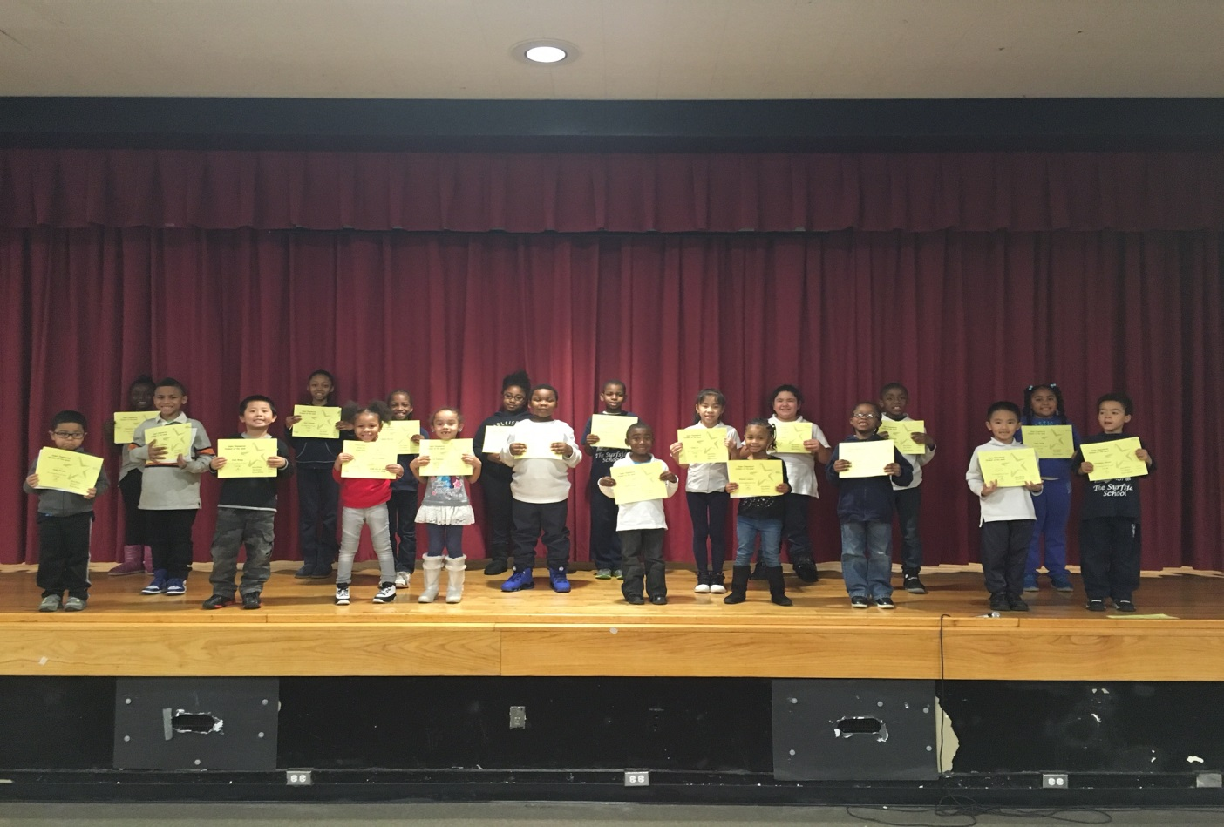

Empowered Students the Week
12/09/16

