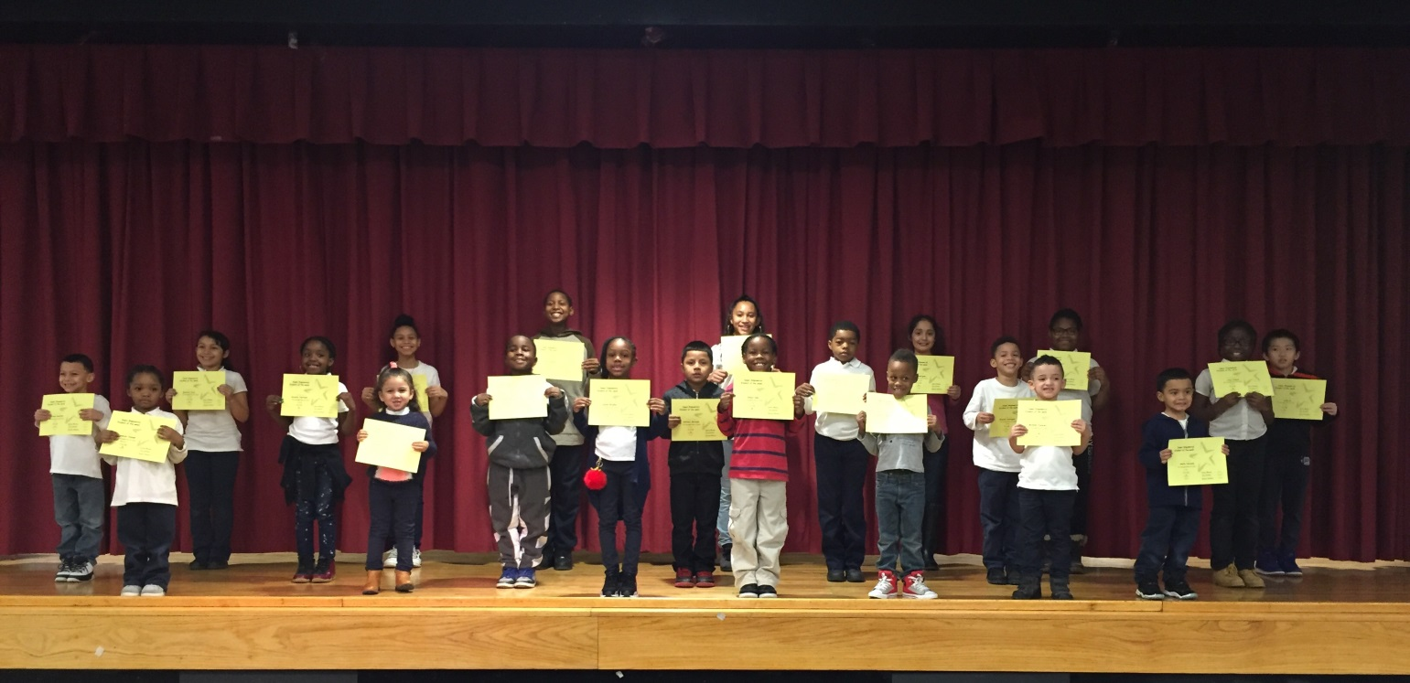
PRE K 131 | Raquel Borrelli
PRE K 145 | Mason Ramsaroop
PRE K 111 | Jeremiah Joseph
K 138 | Amillo Heredia
K 147 | Michael Tavarez
K 140 | Laylah Bradley
1-113 | Michael Santana
1-134 | Anthony Miranda
2-340A | Brayden Rodriguez
2-340B | Heavenly Hightower
3-234A | Deja Dupree
3-234C | Dmari Hall
4-322B | Andy lu
4-322A | Alyssa Rodriguez
4-322D | Aniya Maraj
5-334A | Emily Pillot
5-334C | Doraliza Diaz
K/1 133 | Zaafia Cullum Jr.
1/2 340C | Omari Brown
2/3 234B | Laquana Hayden
3/4 322C | Josiah Grubb
4/5 334D | Darrel Gibson

Week of 01/06/17

